Terms of Reference – Manitoba-Minnesota Transmission Project (MMTP) Monitoring Committee

These terms of reference define the purpose, goals, structure and reporting functions of the MMTP Monitoring Committee. This document was drafted by representatives from many community and organization representatives who participated in Committee meetings between November of 2016 and March of 2018. Signing this document is not an acknowledgement crown consultation has been satisfied nor is it considered support or approval of the project.
Section | Draft Text
Name of Committee | MMTP Monitoring Committee
Purpose: | The purpose of the MMTP Monitoring committee is to:  - support Indigenous participants effective and meaningful participation in the monitoring of the project  - create a platform for understanding issues of concern to Indigenous participants and Manitoba Hydro in order to collaboratively provide informed advice on how to address issues of concern  - share information in a cooperative and transparent manner relating to the environmental issues of the Project
Goals: | - Manitoba Hydro does what they say they would do and is compliant with licence and certificate conditions with the assistance of the MMTP Monitoring Committee  - The land and water is respected as we use our knowledge to monitor its health  - Leadership, members and staff at my community or organization feel informed about the status of MMTP and information is accessible to those who just want to check in if interested.  - There is a place to discuss topics of interest to us that are beyond MMTP
Invited Members: | Animakee Wa Zhing #37  Anishnaabeg of Naongashiing  Birdtail Sioux First Nation  Black River First Nation  Brokenhead Ojibway Nation  Buffalo Point First Nation  Canupawakpa Dakota Nation  Dakota Plains Wahpeton First Nation  Dakota Tipi First Nation  Iskatewizaagegan #39 Independent FN  Long Plain First Nation  Northwest Angle #33 First Nation  Peguis First Nation | Roseau River Anishinabe First Nation  Sagkeeng First Nation  Sandy Bay Ojibway First Nation  Swan Lake First Nation  Shoal Lake 40 First Nation  Sioux Valley Dakota Nation  Waywayseecappo First Nation  Manitoba Metis Federation  Aboriginal Chamber of Commerce  Assembly of Manitoba Chiefs  Dakota Ojibway Tribal Council  Southern Chiefs Organization  Manitoba Hydro  Manitoba Sustainable Development
Quorum: | Six community or organization representatives and one MH representative
Roles and Responsibilities: | - All members of MMTP Monitoring Committee  - communicate outcomes and information from Committee back to leadership and community/organization  - convey information, concerns and questions from leadership and community/organization to MMTP Monitoring Committee  - Respect confidentiality of information shared at meetings  - After initial activities for 2018 have been established, annually, between October 2018-2020 set out in a workplan activities it intends to undertake to reach goals. This workplan should be submitted to Manitoba Hydro in October of each year.  - Decisions are made by majority vote during meetings. From time to time a decision-making committee may be tasked with specific objectives and authority to make decisions on behalf of the entire Committee.  - Participating Communities and Organizations  - Participate at whatever level is preferred by community/organization  - If involved, share information and receive information from representative  - Share concerns and problem solve issues about the Project within the committee  - Manitoba Hydro  - Share information and listen to concerns brought forward  - Provide resources within reason to support committee activities  - Be open and transparent with committee  - Respect confidentiality of information shared at meetings  - Fund annual workplan developed collaboratively with committee  - Manitoba Sustainable Development  - To listen and provide input where appropriate.  - MMTP Committee Monitors  - To be determined with Manitoba Hydro and the Monitor Hiring Subcommittee
Resources: | Communities and Organizations:  Manitoba Hydro  - Budget (see details in Section 5)  - Staff  Communities and Organizations  - Staff time

Reporting function: | - Minutes of MMTP Monitoring Committee are shared with:  - Invited participants  - All communities and organizations  - Manitoba Hydro  - Committee members are responsible for  - keeping their respective community or organization informed of information shared and discussions held at committee meetings (please see Appendix A for template)  - sharing community or group feedback and concerns with the MMTP Monitoring Committee at meetings  - Monitors hired by the Committee will share updates with the Committee (template to be developed)  - All subcommittees report to the MMTP Monitoring Committee.
Meetings | MMTP Monitoring Committee  - Pre Construction and Construction – four times a year  - Operationally – to be determined
Monitor Hiring Subcommittee | A motion was passed on March 1, 2018 to create a hiring subcommittee involving:  - Tammy Walters - Dakota Plains Wahpeton First Nation  - Mike Sutherland - Peguis First Nation  - Stephen Howitt - Manitoba Metis Federation  - Patricia Mitchell - Black River First Nation  - Sarah Coughlin – Manitoba Hydro  to expire one year from today’s date and develop the hiring process and the hiring of monitors. (The motion was moved by Maurice Myran and Cameron Hall seconded. All were in favour).
Communications Subcommittee | A motion was passed on March 1, 2017 to create a communication subcommittee involving:  - Darryl Taylor - Dakota Tipi First Nation  - Maurice Myran - Long Plain First Nation  - Terry Brown - Aboriginal Chamber of Commerce  - Maria M’Lot – Manitoba Hydro  to expire one year from today’s date and develop a communication process. Tom Anderson moved the motion and Eric Cameron seconded the motion. All were in favour).
External Funding Exploration Subcommittee | A motion to create a funding subcommittee involving  - Terry Brown - Aboriginal Chamber of Commerce  - Mike Sutherland - Peguis First Nation  - Lindsay Thompson – Manitoba Hydro  to expire one year from today’s date and explore leveraging other funding resources (Howard Nelson moved the motion and Darryl Taylor seconded the motion. All were in favour ).

Dispute Resolution | This was tabled for another meeting.
Line of communication | 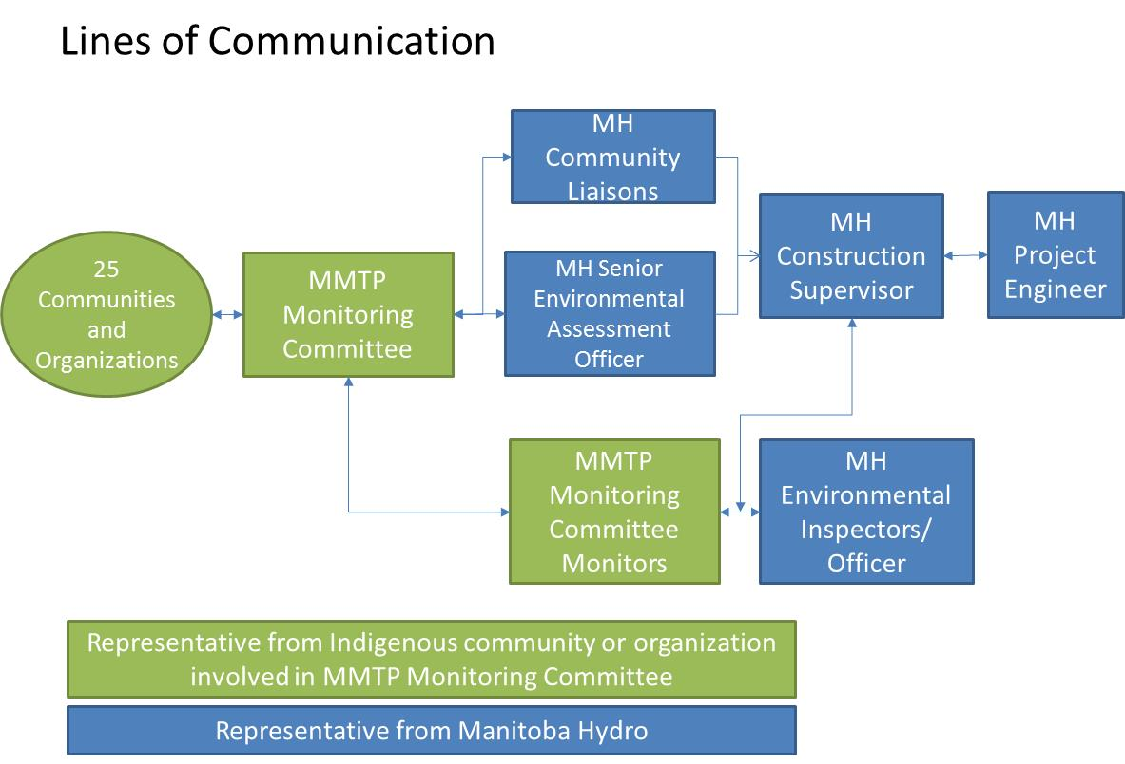

- GOAL: Manitoba Hydro does what they say they would do and is compliant with licence and certificate conditions with the assistance of the MMTP Monitoring Committee
  - TASK 1.1 - Create a summary of all conditions and commitments made by MH and share with Monitoring committee members. This report will be shared with the committee once complete (share online).
    - Scope: A document is prepared that outlines all Provincial and federal commitments required for the project as well as commitments made by Hydro in the environmental impact statement, the CEC Hearing and in supplemental documents. The document and commitments will be written in plain language, and understood to a non-technical audience. Identify applicable / relevant measures for committee.
    - Schedule: Presented to Monitoring Committee in March 1, 2018
    - Budget: 5 days MH time
    - Success looks like: Monitoring members understand and can access MH commitments for the Project.
  - TASK 1.2 – Offer a focused workshop to train those interested in compliance monitoring
    - Scope: Monitoring committee members have indicated that more training is needed for those who may be interested in environmental monitoring.
    - Schedule: one month prior to construction start.
    - Budget: 3-4 days MH time (x2 staff) to prep and host workshop
    - Success looks like: Environment monitors feel prepared and welcome to participate in Project monitoring.
  - TASK 1.3 – Hire environment monitors as determined by a subcommittee to participate in compliance monitoring with Manitoba Hydro. Subcommittee members include representation from Dakota Plains Wahpeton Nation, the MMF, Black River First Nation, Manitoba Hydro and Peguis First Nation). Contracts will be set up with Manitoba Hydro and the communities/organization relevant to monitors hired (similar in structure to contracts used for Bipole III). Administration fees will be provided to the communities for administering the contract.
    - Scope: Monitors will participate in compliance monitoring as well as monitor construction as it progresses. Monitors will prepare and share reports as defined in Task 3.2 monthly as well as during events. Monitors will also take photos and share progress updates on some type of project or social media site. Also, provide an orientation prior to start date so monitors feel comfortable with job duties and compliance requirements
    - Schedule: hired for length of construction (estimated for up to 2 years). It is noted that communities would like a distinction between construction and maintenance, and that there may also be maintenance needs that could include hiring through this subcommittee.
    - Budget: Wages to be determined and based on job expectations and experience.
    - Success looks like: Manitoba Hydro contractors are in compliance with licence conditions and commitments are met. Monitors know what to look for and how to discuss concerns with contractors or MH representatives. Monitors have gained training and experience which they can transfer to other job opportunities.

  - TASK 2.1 - Have ceremonies at the onset on project construction, during construction and post construction
    - Scope: Consider having two or three ceremonies including sweats at the onset on project construction, during construction and post construction. Ask Chief Pashe of Dakota Tipi to lead a ceremony on the right-of-way prior to construction start to show respect to the land. Also, discuss holding a water ceremony lead by women. The ceremonies could involve two or three medicine people. Potentially invite leadership from each community and organization to participate. Suggested locations include a park located adjacent to the new right-of-way, near the area we toured last November, and a water crossing. There is interest in also holding a ceremony on private land.
    - Schedule: Just prior to construction, during construction and post construction
    - Budget: up to $10,000 - $15,000 (mainly honorariums, mileage, a meal)
    - Success looks like: Ceremonies are held and those involved felt it was done properly.
  - TASK 2.2 - Complete botanical monitoring of right-of-way and surrounding area.
    - Scope: Conduct botanical monitoring in the area of the Project between Sundown and the border crossing (on the right-of-way and in close proximity). The Phase 1 Aboriginal Traditional Knowledge Study will be used to inform the study, as well as self-directed studies from any other community who wishes to share information. Vegetation sampling should involve community members who may be interested in participating, and outcomes will be shared at a MMTP Monitoring Meeting. Deliverables will include a report identifying plants of importance and the location of these plants. The MMTP Monitoring Committee will work with MH to develop a plan to protect them as best practicable during construction. This report will be signed off by the MMTP Monitoring Committee. Mileage will be provided for those interested in participating.
    - Schedule: June, 2018
    - Budget: up to $13,500
    - Success looks like: Species and spaces important to Monitoring Committee members are noted and protected in a manner that is practicable for a right-of-way in the area of the unsurveyed portion of the right-of-way.

  - TASK 3.1 – Formalize the MMTP Monitoring Committee.
    - Scope: Hold four MMTP Community Monitoring meetings a year to discuss project progress, events, information sharing, concerns and learnings.
    - Schedule: hold meetings on a quarterly basis, with additional meetings as required, on the first Wednesday of November, January, April/May and October each year until project is in service, then reconvene to determine meeting schedule moving forward
    - Budget: 4 x $4,000 = up to $16,000/year
    - Success looks like: Meetings are well attended and participants and MH find the committee an effective platform for sharing project progress, discussing concerns and proposing solutions. Indigenous community or organization leadership and MH construction representatives attend meetings periodically and feel welcome to attend.
  - TASK 3.2 –Develop a Monitoring Committee members report structure (See Appendix A)
    - Scope: Develop a report format that will be used by Monitoring Committee members to bring back to leadership. An online version complements this report on the Project website. Authorship of the report is by Monitoring Committee members (Committee members ‘own’ the report) so that members have more clout when sharing with leadership. These reports are shared with Manitoba Hydro. The Monitoring Committee develop an agreed to summary report based on the above that can be shared with Provincial environment officers or conservation officers (as appropriate for region). An annual report will also be developed to summarize activities and accomplishments for the previous year.
    - Schedule: February/March, 2018
    - Budget: in kind – Manitoba Hydro/Committee
    - Success looks like: A report template is created that is simple to create, share and easy to understand. A Project website is easy to navigate and complements the paper report.
  - TASK 3.3 – Start some type of project or social media page for Monitoring Committee members and environment monitors.
    - Scope: Start a webpage that Monitoring Committee members can join to see regular updates, ask questions and have construction provide responses. MH will need to be able to respond to questions.
    - Schedule: Start now to develop group.
    - Budget: 5 days/year MH staff
    - Success looks like: A page is created that includes Monitoring Committee members. A link to community/organization web sites are included.

  - TASK 4.1 – Issues that do not pertain to MMTP will be referred to Indigenous Relations at Manitoba Hydro for follow up and response.
    - Scope: An Indigenous Relations lead will manage communications with communities and organizations on an ongoing basis. Response will be expected within 14 days not with a final answer but an indication of follow up.
    - Schedule: ongoing
    - Budget: as required
    - Success looks like: Create an issue matrix that provides a summary of all issues raised and where they are at with the response process and provide average response time. Communities and organizations have a manner in which to share concerns beyond MMTP and feel heard.
  - TASK 4.2 – Routing – develop a better way to include Indigenous perspectives in routing decisions
    - Scope: Manitoba Hydro will host a workshop to develop inputs to the transmission line routing process aimed at understanding and representing areas of interest to Indigenous communities in southern Manitoba.

    - Schedule: fall 2018
    - Budget: 6-8 days MH time (x2 staff) to research approach from other provincial governments and utilities, prepare and host workshop
    - Success looks like: Provide survey to community membership and outline preferred approaches and assess what Indigenous communities and organizations feel clearly incorporates Indigenous concerns in future transmission line routing processes.

Budget
An annual work plan and budget will be prepared each fall by the Committee. The budget will be reviewed by Manitoba Hydro and funded within reason if it meets the reimbursement policy, and meets the intent of this terms of reference.
The MMTP Monitoring Committee may seek additional funding opportunities to support goals. The group will explore leveraging other funding resources to determine whether this is appropriate and suitable (see External Funding Exploration SubCommittee, above).
Signing this document is not an acknowledgement that crown consultation is satisfied nor is it considered support or approval of the project. These terms of reference define the purpose, goals, structure and reporting functions of the MMTP Monitoring Committee. The Terms of Reference described in this document are supported by:

Appendix A – Communications Template
Manitoba-Minnesota Transmission Project Monitoring Committee Update
[Insert Date] Update and Author

Schedule Update
CONSTRUCTION (if approved)
We are here

operation
Regulatory Review

Update from Committee Meeting
Example: The MMTP Monitoring committee met again on March 1st to review a draft terms of reference. The committee made the following decisions:
- The text of the terms of reference
- To develop three subcommittees (hiring, communications and a committee to explore other funding options)
- To ask communities and organizations to sign the terms of reference with a leadership brief to describe the committee to date

Update from Monitors
This is where monitors can provide an update, once hired.

Update on Achieving Goals
Goal | Describe Progress
- Manitoba Hydro does what they say they would do and is compliant with licence conditions.
- The land and water is respected as we use our knowledge to monitor its health.
- Leadership, members and staff at my community or organization feel informed about the status of MMTP and information is accessible to those who just want to check in if interested.
- There is a place to discuss topics of interest to us beyond MMTP. | Ongoing

A definition of compliance will be provided by Manitoba Sustainable Development representative.

